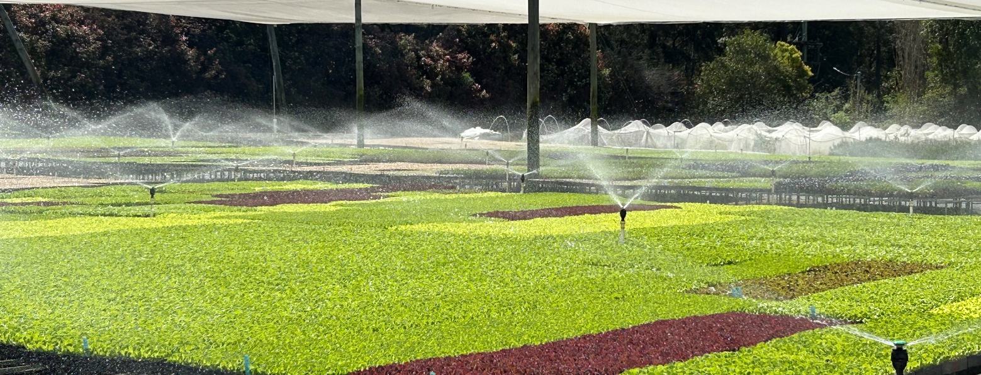

Nursery WaterWise Irrigation Workshop

Local Land Services Greater Sydney together with the Nursery & Garden Industry NSW are offering a subsidised 2-day course for nursery irrigators looking to receive the latest information on nursery irrigation management.

The course is a mix of theory and practical exercises, and each participant will receive a free copy of the “Managing Water in Plant Nurseries” publication (please see overleaf for course outline).
This is an excellent opportunity for nursery apprentices to gain a good technical understanding of irrigation fundamentals.

Cost
$200 per person (capped at two per nursery business) which includes lunch, morning and afternoon tea on both days.

Presenters:
- Bill Yiasoumi, Nursery Irrigation Consultant
- Matthew Plunkett, Greater Sydney Local Land Services.

Region
Greater Sydney Local Land Services

Date and time
Day 1 – Thursday 13 November 2025
9am to 4pm
And
Day 2 – Thursday 20 November 2025.
9am to 2pm

Location
Greater Sydney Local Land Services Demonstration Farm
40 Edwards Road, Richmond Lowlands, 2753

RSVP
Places are limited so register now at:

https://events.humanitix.com/nursery-waterwise-irrigation-workshop

Contact
Matt Plunkett on 0428 978 390 or matthew.plunkett@lls.nsw.gov.au
URSERY WATERWISE WATERWORK PROGRAM

Day 1 – Thursday 13 November 2025
Irrigation Systems
• Overhead sprinklers, mobile booms, hand watering
• Practical Session: Evaluating sprinkler performance
• Drip irrigation
• Bottom watering systems
• Operating and Scheduling irrigation systems
• Irrigation system audit
• Irrigation system design.

Day 2 – Thursday 20 November 2025
Water Supply and Treatment
• Water supply and irrigation requirements
• Water treatment (includes water testing)
• Water disinfestation.
Drainage and Recycling
• Site assessment for drainage
• Drainage system design
• Dealing with drainage water
• Review and wrap up.

